**Usage of Subversion and Mercurial**

**Subversion (SVN) Commands and Usage**

Subversion is a centralized version control system.

**1. Update and Install SVN**

Sudo apt update

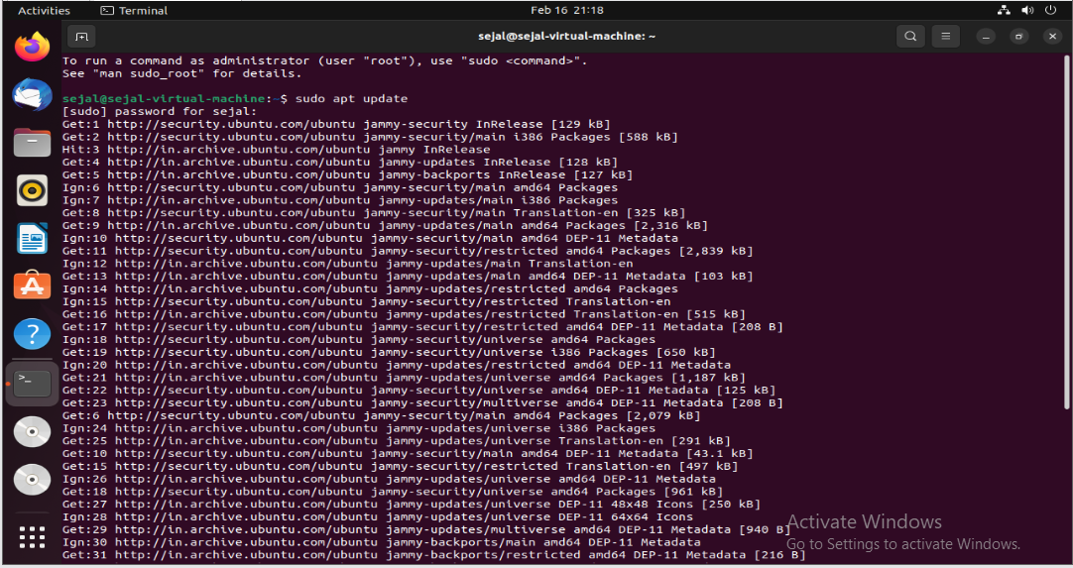

sudo apt install subversion # Debian-based

sudo yum install subversion # RHEL-based

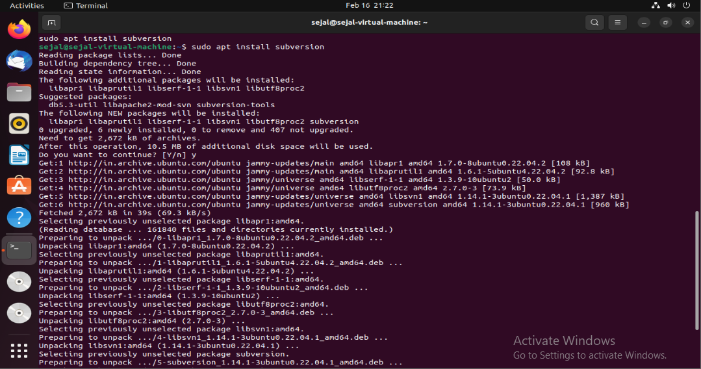

**2. Create a Repository**

svnadmin create my_repo



**3. Checkout a Repository**

svn checkout file:///path/to/my_repo my_project

cd my_project

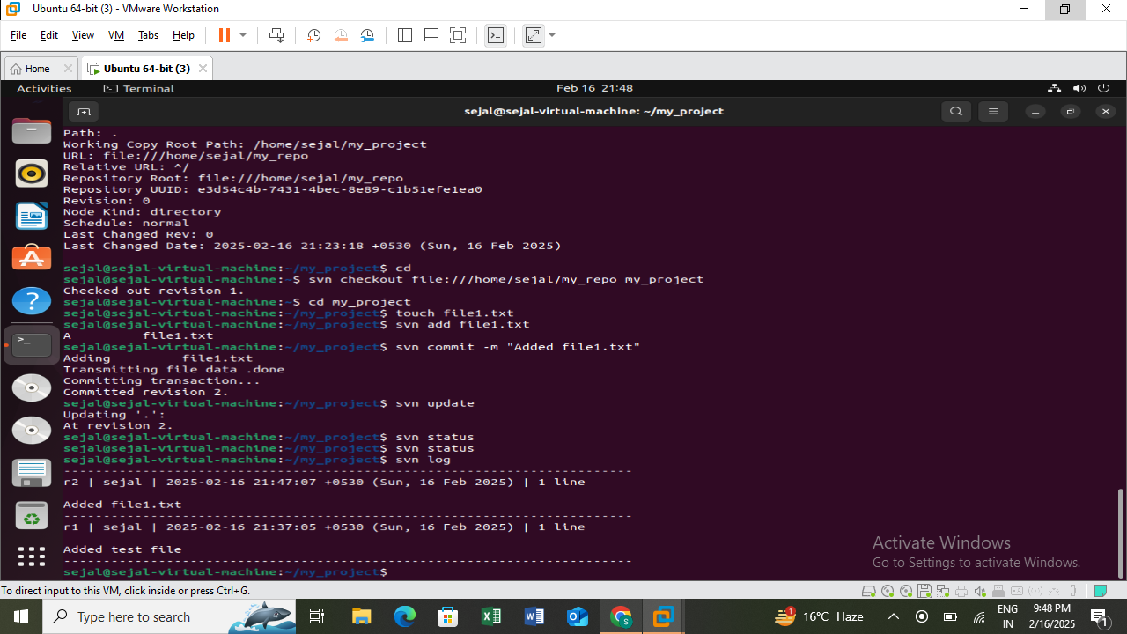

This creates a **working copy** of the repository in my_project.

**4. Add and Commit Files**

svn add file1.txt

svn commit -m "Added file1.txt"



svn add marks the file for addition.

Svn commit saves changes to the repository.

**5. Update Repository**

svn update



Fetches the latest changes from the repository.

**6. View Logs**

svn log



Displays commit history.

**7. Remove Files**

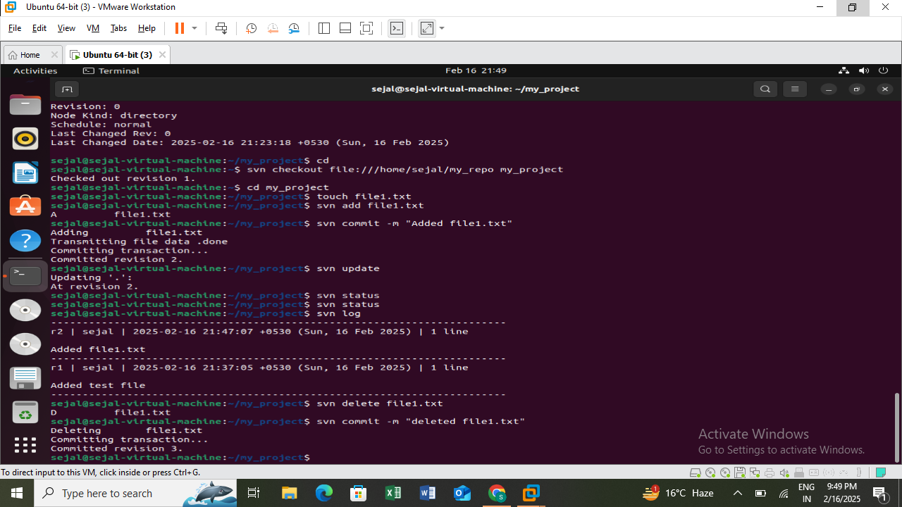

Removes the file**.**

**Mercurial (Hg) Commands and Usage**

Mercurial is a distributed version control system.

**1. Install Mercurial**

* **Windows**: Install TortoiseHg
* **Linux/macOS**:

sudo apt install mercurial # Debian-based

sudo yum install mercurial # RHEL-based

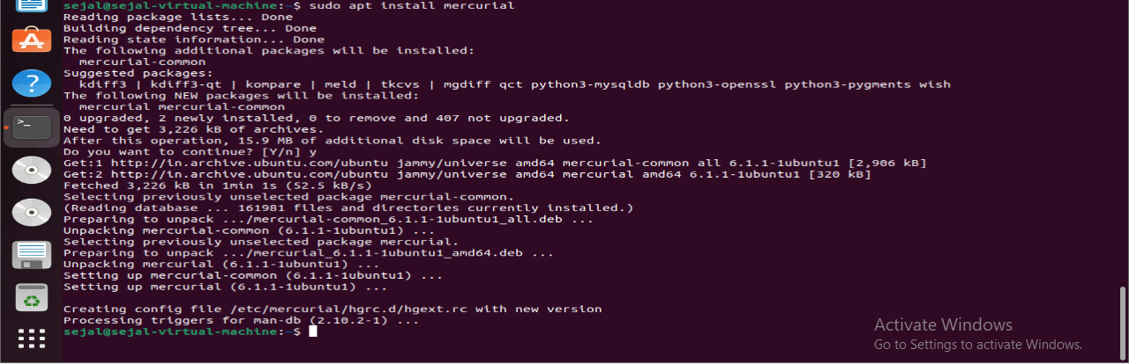

**2. Create a Repository**

hg init my_project

cd my_project

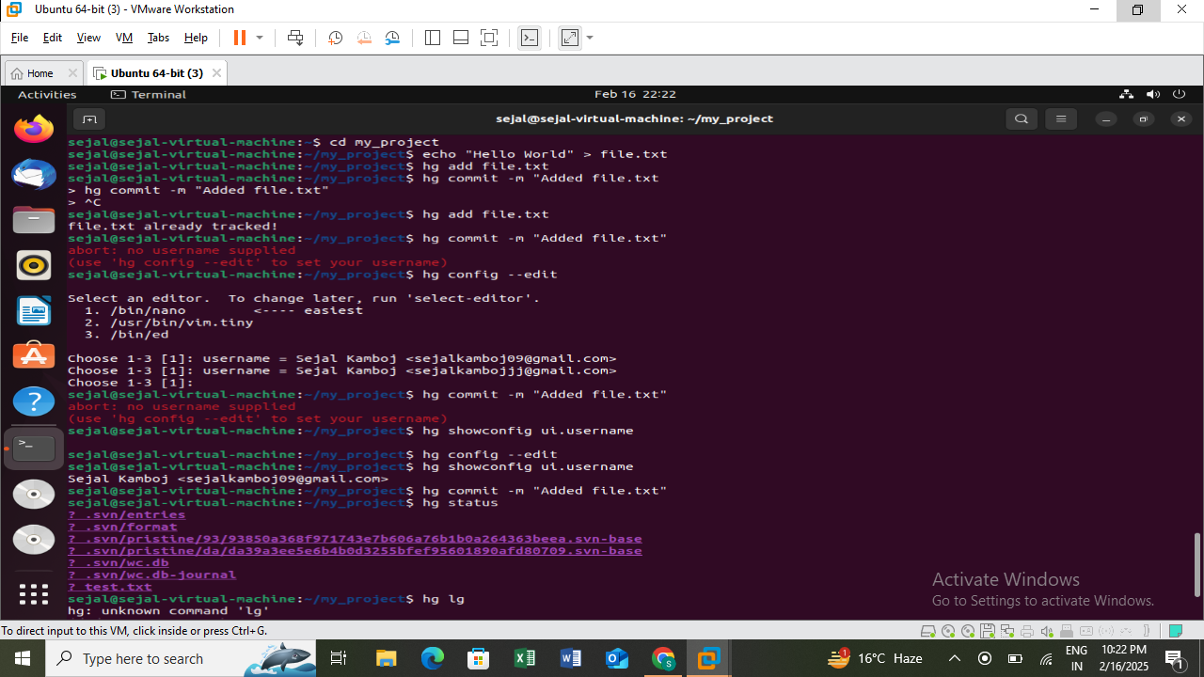

Initializes an empty Mercurial repository.

**3. Add and Commit Files**

echo "Hello World" > file.txt

hg add file.txt

hg commit -m "Added file.txt"



hg add marks the file for addition.

hg commit saves the changes.

**4. View Repository Status**

hg status



Shows uncommitted changes.

**5. View Logs**

hg log



Displays the commit history.